Ascendum presents smart, innovative solutions
at the MAWEV SHOW 2024

ASCENDUM Baumaschinen Österreich GmbH is pleased to announce it is participating in this year's MAWEV SHOW from April 10th to 13th, 2024. With its slogan “Digging, loading and transporting on the construction site of tomorrow,” Ascendum is presenting its new trade fair stand design over a 1700 m² area. The focus is on personal customer contact, new driveline technologies, individual special solutions and Ascendum's all-round offering, which includes construction equipment sales, rentals, spare parts as well as service and repairs.

The brands Volvo CE, Sennebogen and Epiroc are at the center of the Ascendum trade fair appearance and form perfect synergies with the products and services of the partners at the stand, including: Volvo Trucks, Schöller Special Machines (SSM), Volvo Financial Services, Goodyear, Rotobec and Deutsche Leasing.
The Ascendum stand A10 on the West outdoor area this year at MAWEV has an exciting new design. In addition to a demonstration of Volvo’s electric compact machines and a competition sponsored by the Volvo Operators’ Club, visitors to the indoor area will find a 360° experience with smart services, uptime, CO₂ reduction, productivity, and Austrian hospitality at the center.

Premieres of the latest technologies

The construction industry is looking to the future and the issue of efficient, sustainable and resource-saving solutions always arises. Ascendum has set itself the goal of presenting the status and future of battery, electric and hydrogen drives as well as digital assistance systems and telematics solutions at MAWEV 2024.

The Volvo EC230 Electric is celebrating its Austrian premiere at MAWEV. This 23-ton electric tracked excavator offers the same performance as a comparable diesel model, but is emission-free and low-noise and low-vibration. As a general purpose machine, the EC230 Electric is suitable for a variety of jobs including earthmoving, grading, and waste and scrap handling in the recycling and waste segment.

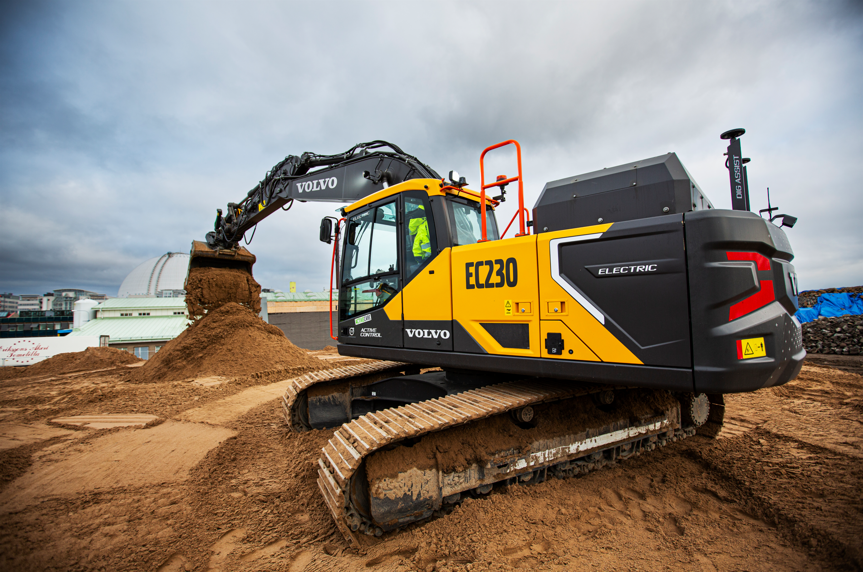
The fully electric Volvo EC230 Electric in action.

The Volvo HX04, the world’s first prototype of a hydrogen fuel cell dumper, will also be presented in Austria for the first time at MAWEV. This prototype, alongside other solutions such as the use of renewable biofuels, shows that several technologies are possible when reaching the goal of decarbonizing the construction industry.

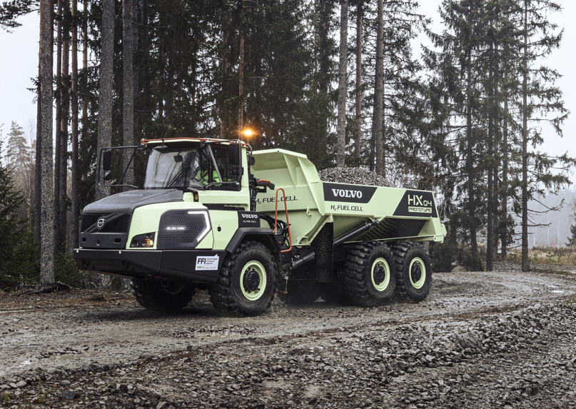
The Volvo HX04 prototype is already being tested.

Things are also getting exciting in the special machines segment. SSM presents the Volvo ECR145 tunnel excavator, which is equipped with a new extinguishing system and a fully hydraulic quick coupler in a tunnel version.

As a world premiere in its size class, the Volvo ECR50 twindrive is being presented for the first time by SSM and ASCENDUM. The compact excavator can be operated both conventionally with a diesel engine and with an additional emission-free electric drive. The power supply is provided via a standard electrical connection on the construction site and enables permanent machine operation in electric mode.
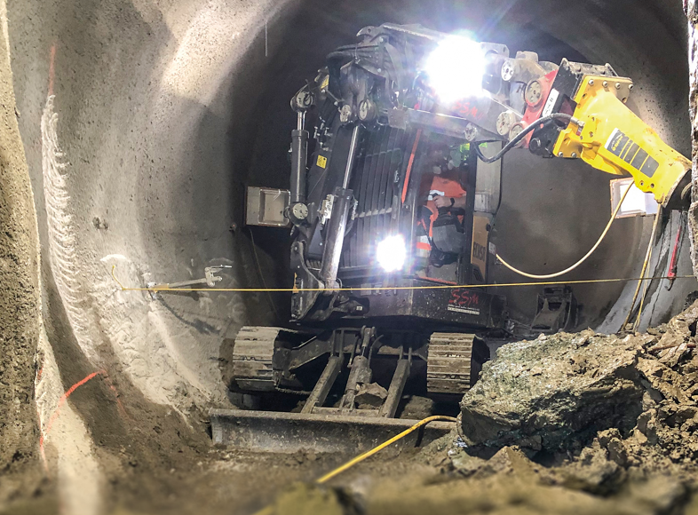
The Volvo ECR50 twindrive will be shown for the first time at MAWEV 2024.
The big brother ECR58 already gives an idea of the special machine.

Ascendum partner Sennebogen is premiering another product in Austria: the 817
Electro Battery, which works with a rechargeable battery. It is a technological milestone for the recycling industry and for everyone who wants to work with maximum flexibility and fully electric power, as the machine can work in battery mode for up to 6 hours without recharging. You can continue working even while charging thanks to the dual power management.

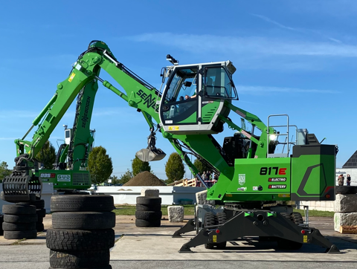
The Sennebogen 817 Battery Electric is already ready for use.

Practical tests at the MAWEV Show

A special highlight will be the live demonstration of the fully electric Volvo compact machines. Participants can test the Volvo L20 Electric and the Volvo ECR25 Electric at the trade fair. See for yourself how an electric construction machine drives and “fill it up with electricity” using on-board chargers or fast chargers.

The Volvo Operators Club will also be represented at the trade fair stand and will qualify Austria’s best operators for the Operators Club Finals 2024 at MAWEV. Any operator can qualify here in a skills competition. The top two will go to the final in Sweden. Registration takes place directly at the exhibition stand.

Time for solutions

“Ascendum’s participation in the MAWEV Show is a great opportunity to inform our customers and partners about the latest technological developments in the construction machinery industry,” says Dr. Thomas Schmitz, Managing Director of Ascendum Baumaschinen Österreich GmbH. “With a focus on smart, innovative solutions, we not only want to present our wide range of machines and services, but also show how we can actively participate in shaping a sustainable future and use our services to increase the productivity and success of our customers. According to Mahatma Gandhi, the future depends on what we do today,” says Dr. Thomas Schmitz.

Sales Director Martin Hubmayer adds: “Our future-oriented sales is the key to turning today’s challenges into tomorrow’s opportunities.”

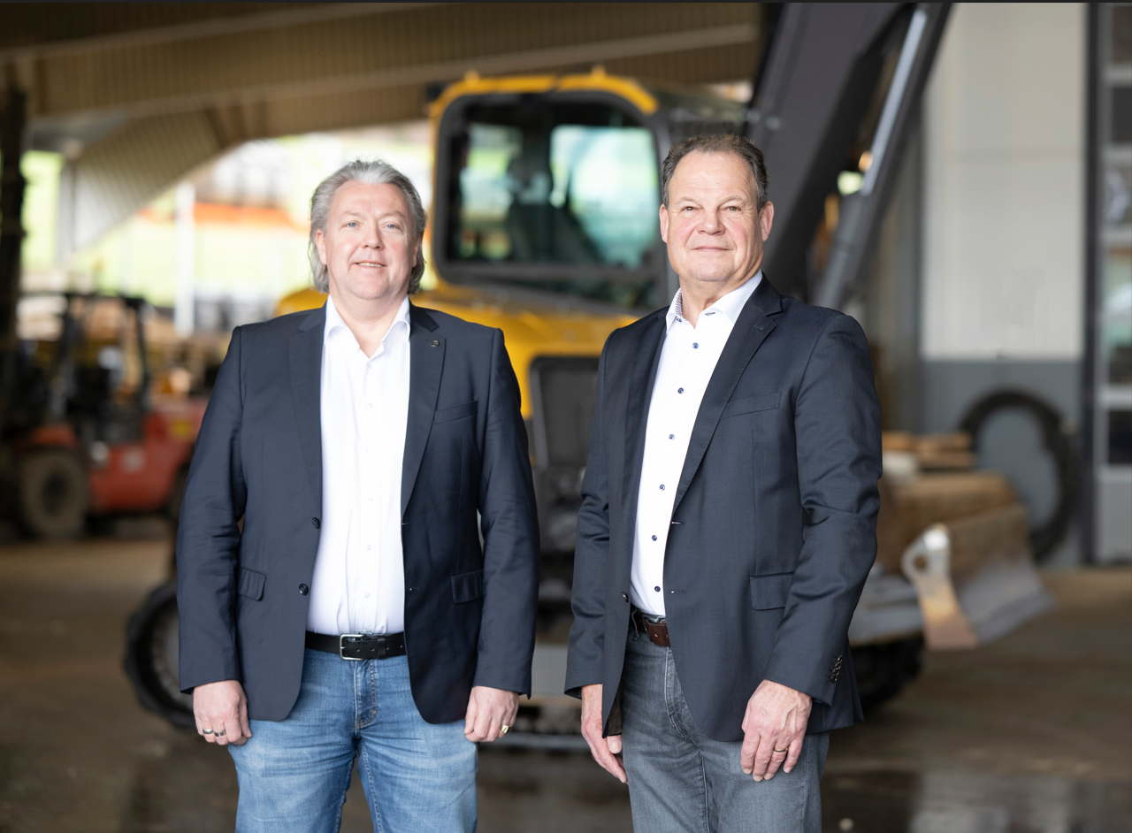
From left to right: Ascendum Sales Director Martin Hubmayer and
Ascendum Managing Director Dr. Thomas Schmitz

Visitors to the Ascendum trade fair stand A10 on the West outdoor area can look forward to informative discussions, live demos, and insights into the most advanced construction machinery technologies. Ascendum Baumaschinen Österreich GmbH is looking forward to welcoming lots of visitors to the MAWEV SHOW 2024 to shape the future of the construction industry together.

For further information or press inquiries please contact:

Press contact
Nina Lindner, Marketing Manager

T +43 (0)664 851 06 69
nina.lindner@ascendum.at
www.ascendum.at

